Medical Social Service & Health Promotion Centre已完成, 另請看【thumbnail及banner講解】

Website: https://kwh.9u1.net/Services/Medical-Social-Service.html

- The top photo is not recommended to delete for the page consistent
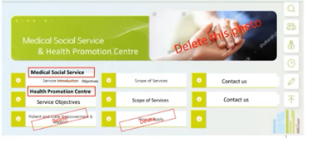
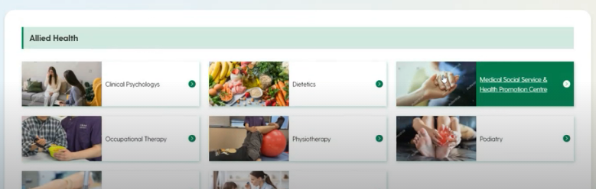
KWH: will provide later, keeping current image first but no need purchase

- Naming,
知道你們部門內會再細分2部分, 類似Obstetrics And Gynaecology
現在你們命名的分式重覆了【Scope of Services】及【Contact us】, 或會導致人閱讀上感混亂
提議會否考慮只保留【Medical Social Service】及【Health Promotion Centre】, 然後把所有有關的內容都放在這2個大分類下?
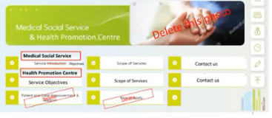
KWH: separate as two page

Occupational Therapy 已完成
Website: https://kwh.9u1.net/Services/Occupational-Therapy.html
- Confirm the layout (description under subtitle or description below photo)
KWH: remove all photo in page (excluding Location), only text on the page
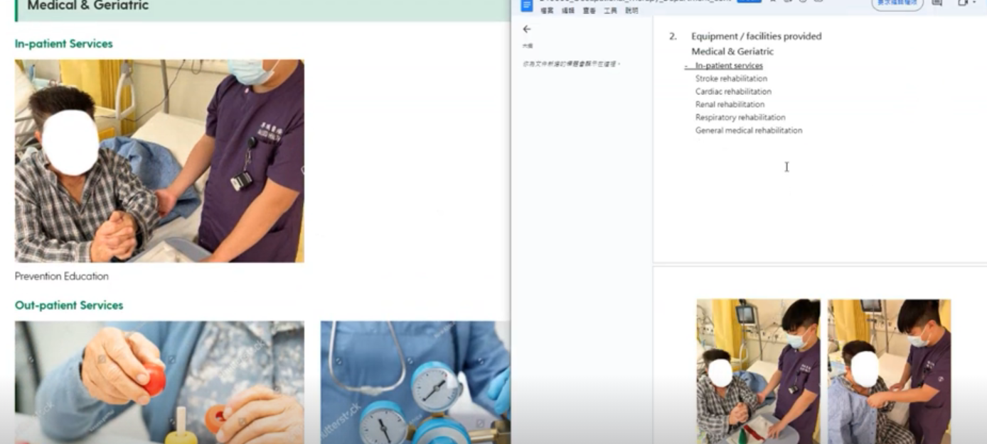
- Consistent wording “Clinics information” -> “Service Hours, Contact Information and Location”
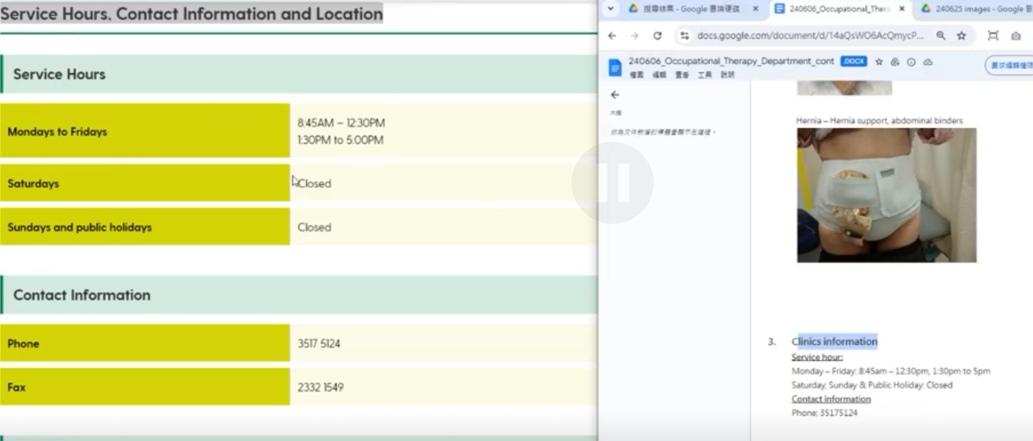
KWH: can keep “Service Hours, Contact Information and Location”
- Which photo is the most updated? KWH: use image name “_DSC6321-Enhanced-NR” in “240625 images”
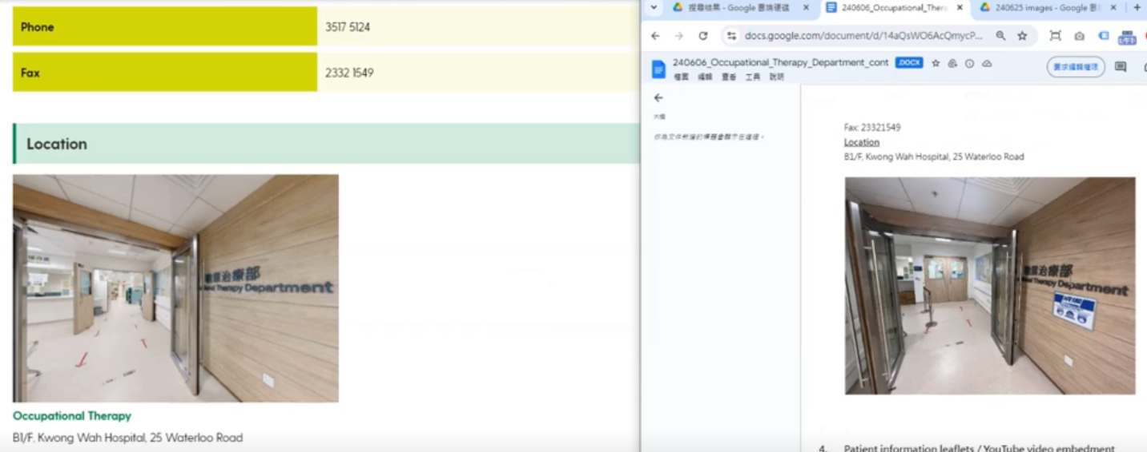
- Empty content, hide first? KWH: hide first
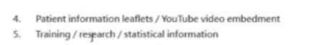

Physiotherapy 已完成
Website: https://kwh.9u1.net/Services/Physiotherapy.html

在Google Drive上的Information Leaflets內容目前只有中文版
Google Drive: https://drive.google.com/drive/u/0/folders/1yd_DFQiVHXwExjfOq71zCPOkG1Z5cKRh
請確應是否3種語言都是顯示以上Google Drive的文件, 而不是有不同語言的文件
KWH: show the Chinese language version leaflets in all language pages but the headings should be in corresponding language

請確應英文版的內容是否已是最終版本? 如是, 將會聯絡翻譯員再較對一次
目前的翻譯文件在:
https://drive.google.com/drive/folders/1_fBmxMrsR_HQOPE4j5ENeBiBpIZEN1et
KWH: confirmed Eng version, please process translation

Podiatry 已完成
Website: https://kwh.9u1.net/Services/Podiatry.html

請確應圖片是否使用這張? 如是, 將會代為購買無水印版
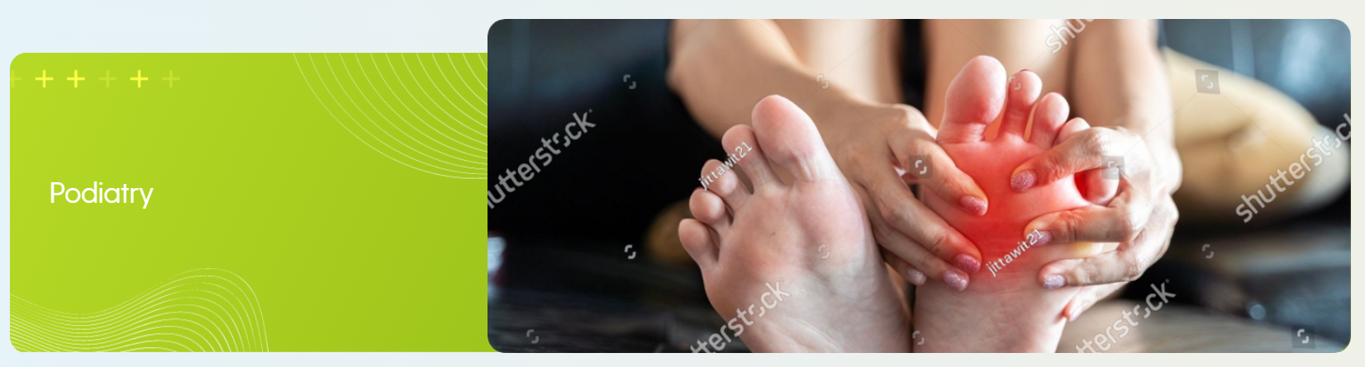
KWH: received user’s reply, at POD dept folder, named “240912 Podiatry photo”

請確應英文版的內容是否已是最終版本? 如是, 將會聯絡翻譯員再較對一次
目前的翻譯文件在:
https://drive.google.com/drive/folders/1_fBmxMrsR_HQOPE4j5ENeBiBpIZEN1et
KWH: received user’s reply, at POD dept folder, named “240912 Podiatry photo”

Speech Therapy已完成
沒有此頁內容
KWH: copy the page of https://www3.ha.org.hk/kwh/main/tc/service-introduction.asp?service=st

Accident & Emergency 已完成
Website: https://kwh.9u1.net/Services/Accident-Emergency.html

請確應英文版的內容是否已是最終版本? 如是, 將會聯絡翻譯員再較對一次
目前的翻譯文件在:
https://drive.google.com/drive/folders/1_fBmxMrsR_HQOPE4j5ENeBiBpIZEN1et
KWH: confirmed ENG version and provided chinese version at “240405 A&E EDIT final.docx”
KWH: Also, about the Patients and Visitors page, also provided Chinese version at “240405 A&E Part - Patients and Visitors EDIT final”

Anaesthesiology & Operating Theatre Services已在文檔【20240903 - Anaes & OT】上標記回覆
Website: https://kwh.9u1.net/Services/Anaesthesiology-Operating-Theatre-Services.html

請確應英文版的內容是否已是最終版本? 如是, 將會聯絡翻譯員再較對一次
目前的翻譯文件在:
https://drive.google.com/drive/folders/1_fBmxMrsR_HQOPE4j5ENeBiBpIZEN1et
KWH: received user’s comment, at ANAE&OT dept folder, named “20240903 - Anaes & OT”

Diagnostic and Interventional Radiology已完成
Website: https://kwh.9u1.net/Services/Diagnostic-And-Interventional-Radiology.html

請確應英文版的內容是否已是最終版本? 如是, 將會聯絡翻譯員再較對一次
目前的翻譯文件在:
https://drive.google.com/drive/folders/1_fBmxMrsR_HQOPE4j5ENeBiBpIZEN1et
KWH: received comments, comments uploaded to RAD dept folder, named “240906 RAD comments”

Intensive Care Unit已完成
Website: https://kwh.9u1.net/Services/Intensive-Care-Unit.html

有關Information Leaflets , 留意到文件目前是英文版, 請問會有其他語言的文件提供, 抑或是網站3種語言狀態下, 都是下載同樣的英文版文件?
KWH: provided Chinese version at ICU dept folder named “240909 visitor guide”
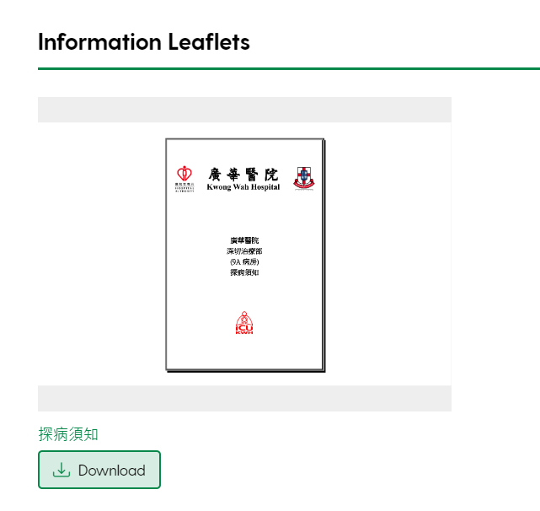

請確應英文版的內容是否已是最終版本? 如是, 將會聯絡翻譯員再較對一次
目前的翻譯文件在:
https://drive.google.com/drive/folders/1_fBmxMrsR_HQOPE4j5ENeBiBpIZEN1et
KWH: translate again first, and please double check with the comments on chinese version at “240415 Dept Web ICU Chinese”

Obstetrics & Gynaecology已完成
Website: https://kwh.9u1.net/Services/Obstetrics-And-Gynaecology.html
KWH: Wrong descriptions on contact information locations, update first, refer to “240418 KWH O&G services introduction V2”
KWH: appreciate to check all content of Service Hours, Contact Information and Location, not only update the wordings with red color
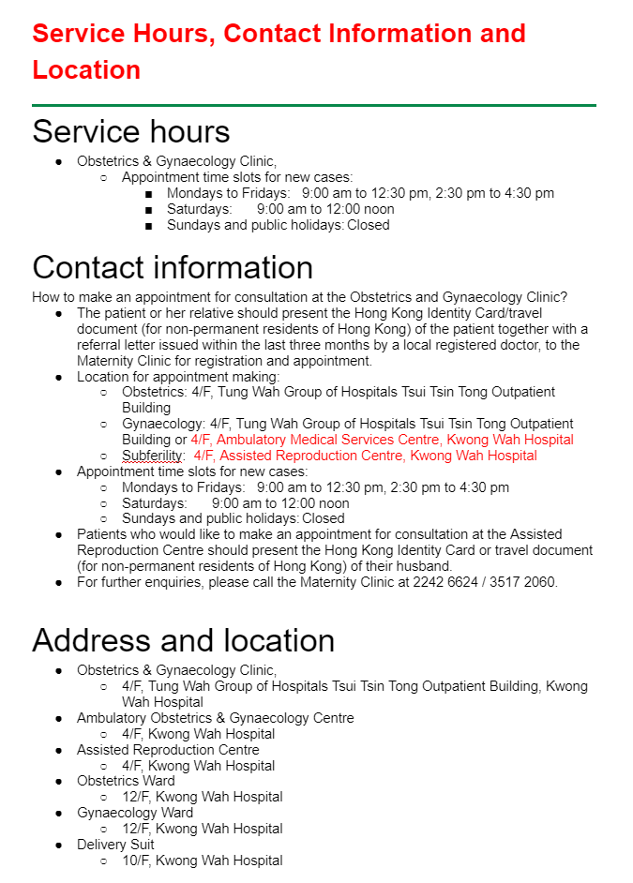

KWH: Wrong photos for all locations, update first
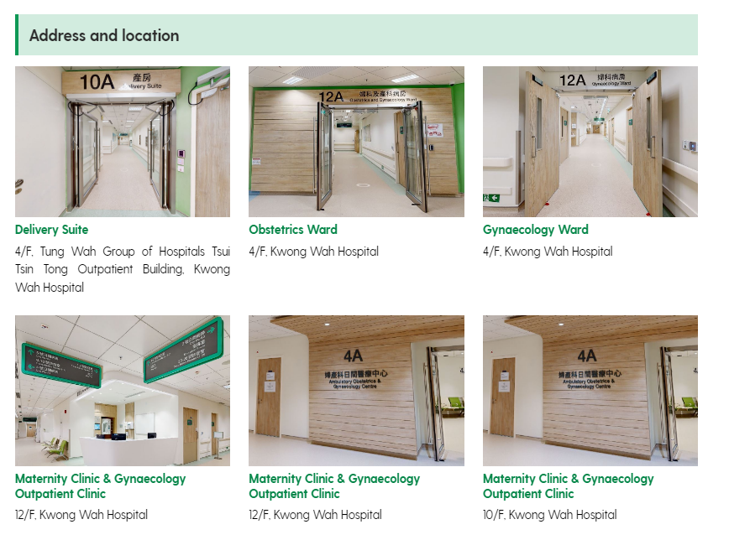

Ophthalmology已完成

Website: https://kwh.9u1.net/Services/Ophthalmology.html

請確應圖片是否使用這張? 如是, 將會代為購買無水印版
KWH: please purchase


請確應英文版的內容是否已是最終版本? 如是, 將會聯絡翻譯員再較對一次
目前的翻譯文件在:
https://drive.google.com/drive/folders/1_fBmxMrsR_HQOPE4j5ENeBiBpIZEN1et
KWH: content confirmed

Paediatrics and Adolescent Medicine已在文檔【240904 P&AM website】上標記回覆
Website: https://kwh.9u1.net/Services/Paediatrics-And-Adolescent-Medicine.html
KWH: received comments, comments uploaded to PAED dept folder, named “240904 P&AM website”

Pain Medicine請看【Banner講解】
Website: https://kwh.9u1.net/Services/Pain-Medicine.html

請確應圖片是否使用這張? 如是, 將會代為購買無水印版
KWH: provided some photos but dun know which photo is better, please help to select one.
if there is no photos suitable, then remove the banner image first


已完成有關Patient Information, 文件無法下載, 請提供
KWH: download file offline and you could open it in the downloaded document.
並告知文件是否需要分為3份, 以便在3種不同語言下下載? KWH: single version in all language pages
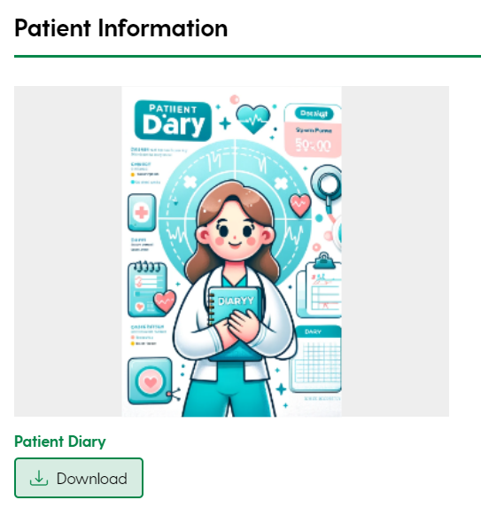
已完成有關Education Videos, 目前YouTube只有繁體中文版本, 未知是否在3種不同語言下都是顯示相同的繁體中文連結?
KWH: added new videos for education at “Pain Medicine [PAIN]” -> “240905 patient education” folder
KWH: single version in all language pages
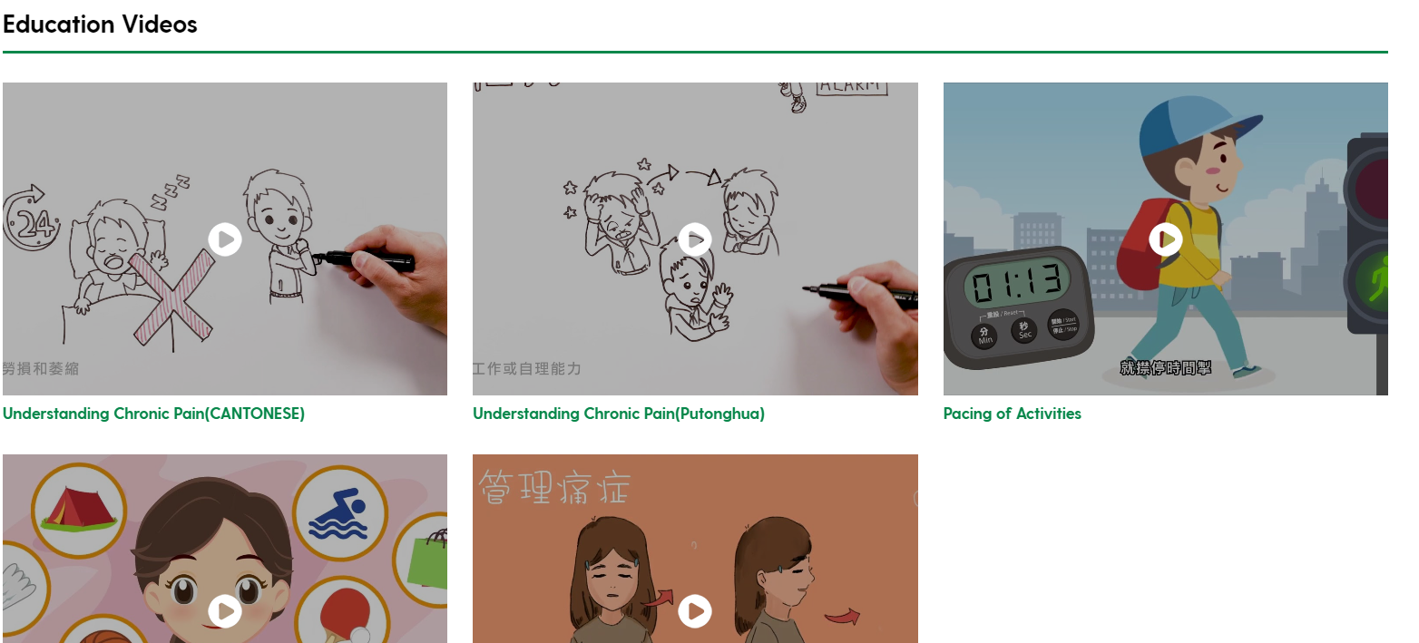

已完成有關Publications, 文件無法下載, 請提供
KWH: download file offline and you could open it in the downloaded document.
並告知文件是否需要分為3份, 以便在3種不同語言下下載?
KWH: single version in all language pages
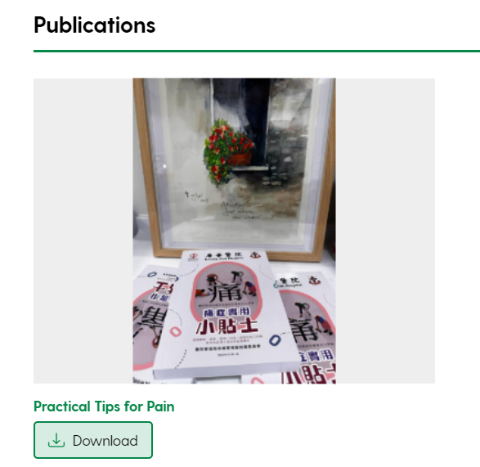

請確應英文版的內容是否已是最終版本? 如是, 將會聯絡翻譯員再較對一次
目前的翻譯文件在:
https://drive.google.com/drive/folders/1_fBmxMrsR_HQOPE4j5ENeBiBpIZEN1et
KWH: user want to check the translated document before update, please translate once first

Shroff Office已完成

Website: https://kwh.9u1.net/Services/Shroff-Office.html

有關Patient Self-services Information, 是否確應選用目前顯示的圖庫圖片, 如是, 將會代為購買無水印版



請確應現在每一段文字右旁的圖片是否確應選用目前顯示的圖庫圖片, 如是, 將會代為購買無水印版
KWH: provided new images to replace, at Shoff Office folder named “240912 images”

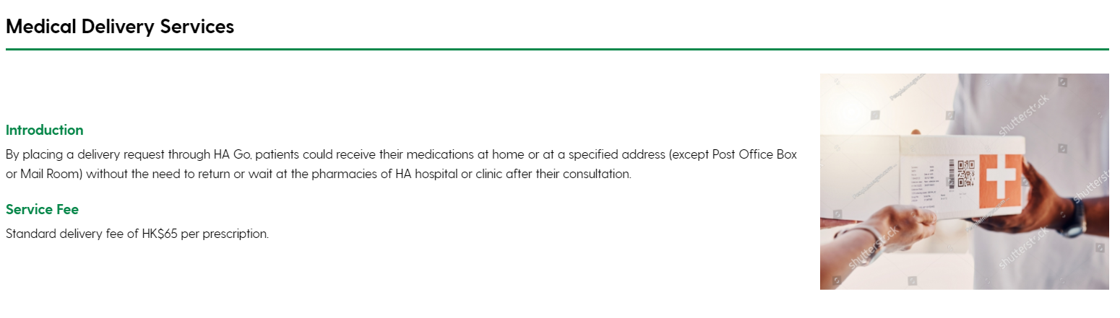

請確應英文版的內容是否已是最終版本? 如是, 將會聯絡翻譯員再較對一次
目前的翻譯文件在:
https://drive.google.com/drive/folders/1_fBmxMrsR_HQOPE4j5ENeBiBpIZEN1et
KWH: received user’s comment, at Shoff Office folder named “240912 Comment_ Shroff Office web page”

Community Nursing Service (Outreach Service) 已完成

Website: https://kwh.9u1.net/Services/Community-Nursing-Service.html

文件無法下載

有關Referral Logistic 及Service Area, 文件無法下載, 請提供
KWH: download file offline and you could open it in the downloaded document.
並告知文件是否需要分為3份, 以便在3種不同語言下下載?
KWH: will update later
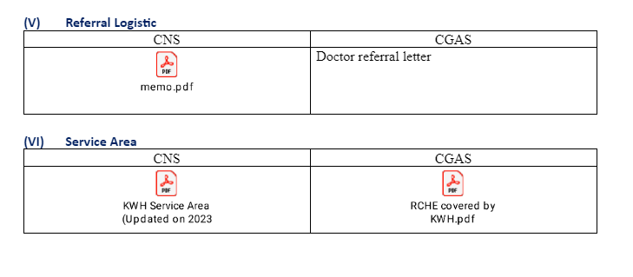

Pharmacy
Website: https://kwh.9u1.net/Services/Pharmacy.html
KWH: received comments, comments uploaded to Pharm dept folder, named “20240903 - pharm”

Chinese Medicine General Outpatient Clinic已完成

沒有此頁內容

KWH: do redirection
https://www.tungwah.org.hk/en/medical/mh-introduction/chinese-medicine/chinese-medicine-general-outpatient-services/#hospital2

TWGHs Integrated Diagnostic & Medical Centre已完成
KWH: do redirection
https://www.tungwah.org.hk/en/medical/mh-introduction/screening/twghs-integrated-diagnostic-medical-centre/

Integrated Chinese & Western Medicine已完成
在Google Drive: https://drive.google.com/drive/u/0/folders/1wp__uqg46xCfPC3H_xd5u-xn8muS1h-S
TWGHs Integrated Chinese and Western Medicine Treatment Centre 的內容, 不確定是放在網站的【Integrated Chinese & Western Medicine】抑或是【 TWGHs Integrated Diagnostic & Medical Centre】
或其實應該只需要一個頁面即可, 現在是多餘重覆了?
KWH: 做錯版
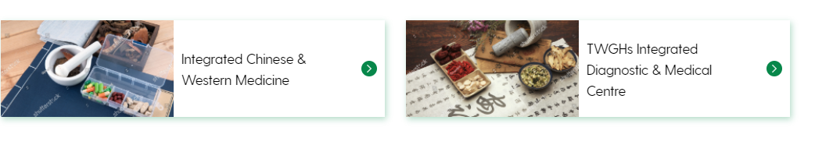

Well Women Clinic已完成

沒有此頁內容

KWH: do redirection
https://www.tungwah.org.hk/en/medical/mh-introduction/screening/well-women-clinic/

